Healthy Eating Policy

Introductory Statement:
The focus of this policy is to support parents and pupils in relation to healthy eating habits from an early age. Practical suggestions are included, alternative snacks and treats as well as possible nutritious lunches.
This policy is linked to:
- SPHE: Taking Care of My Body - Food and Nutrition and Making Choices
- Science: Myself - Human Life Processes
Objectives:
- To help children and parents make healthy food choices
- To improve the children's concentration and energy levels
- To develop an awareness of nutrition i.e. ingredients of food
Guidelines:
- A healthy lunch-box contains a piece of food from the lowest 4 levels of the Food Pyramid
- Snacks for small break include fruit, vegetables, flapjacks, fruit yoghurts, fromage frais, crackers and raisins.
- Healthy fillings for sandwiches are encouraged
- The following foods are NOT permitted for lunch at anytime following a parental survey:
- Cake: Madeira/Lemon drizzle/Carrot/Fruit
- Mini Pancakes
- Mini Chocolate bar/Chocolate sweets
- Funsize jellies
- Chocolate biscuits
- Chocolate Muffins
- Croissants
- Chocolate cereal bars
- Chewing gum
- Large bars of any kind
- Crisps
- Fizzy drinks
- Popcorn
- Chocolate Spread
- Nutella
- Milk (due to a lack of refrigeration space)
- Water is encouraged, although juices (no added sugar/tooth-kind) may be used as an alternative.
- Please be aware that quite a lot of lunch items available are “dressed-up” as healthy, nutritious foods but which in reality are laced with sugar and other additives. We appeal to your common sense in this regard.
Exemptions:
- Children are allowed a small treat on Friday Only. The following is a list of the treats agreed following a parental survey:
- Plain biscuit – digestive, rich tea, fig roll, ginger nut
- Bun: plain/chocolate chip/bun with icing
- Chocolate/Yoghurt Rice Cake
- Children will be allowed to have a treat day at the end of each term.
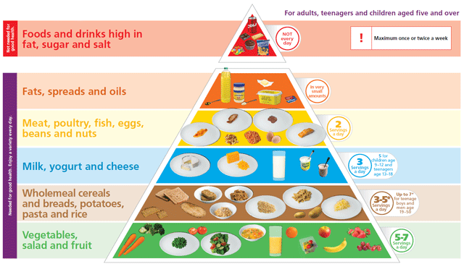
Lots of Great & Tasty Ideas
Snacks:
Try ... whole-meal muffins, raisins, scones, flapjacks, raw vegetables, fruit, seeds, dried fruit, fruit yoghurts, crackers, fromage frais or bread
Drinks:
Gulp Down ... water, unsweetened fruit juices, yoghurt drinks, vegetable drinks, or smoothies
Carbohydrates:
What About ... whole-grain breads, rolls, bagels, wraps, oatcakes, crackers, pasta, rice, plain rice cakes or plain cereal bar.
Fillings could include: cheese, tuna, hummus, cold meats, lettuce, cucumber, tomato, onion, peppers, coleslaw or salad.
Fruit:
Chop On ... apple, orange, banana, grape, pear, plum, kiwi, melon, grapefruit, pineapple and many more ...
Raw Vegetables:
Crunch On ... carrots, peppers, cucumber, broccoli, tomatoes, sweetcorn and many more...

Ratification and Communication
This policy was ratified by the BOM on __________ 2023.

Signed: ________________________ Chairperson

Signed: ________________________ Principal

