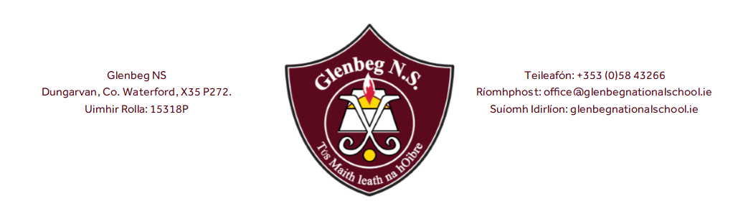

Twitter Usage Policy

The purpose of having a school Twitter account is to:
- share and celebrate the work and achievements of children in Glenbeg N.S.
- communicate with parents regarding specific events & activities
- communicate with new or prospective parents
- communicate with a wider audience regarding positive promotion of school activities, admissions/enrolment dates, advice to parents (eg Covid) etc
- continue advancement of our school communication system with information shared via paper notes, email, website & Twitter
- demonstrate safe and responsible use of social media
- encourage the use of 21st Century technology

Promoting the safe usage of the school Twitter account @GlenbegSchool:
- The school Twitter account will be managed from school devices by designated staff members.
- Designated staff members will monitor all followers and block any who appear to not be school focused.
- The school Twitter account will only follow educationally linked accounts. No personal accounts, unless they are educationally/school linked, will be followed eg. a children’s author, Cumann na mBunscoil, another school.
- The school Twitter account will not reply to any ‘replies’ and/or direct messages on Twitter. This is not the platform to discuss or debate school related issues. Please follow the school’s ‘Parental Communication & Complaints Procedures’ in this instance.
- Our Admissions application form requires written permission from all parents to post pictures of children on our Twitter page. Staff members are also asked for permission to post pictures of them on the Twitter page.
- The school Twitter account will avoid using children’s names where possible. In cases where children’s names are used we will use first names only.
- The school Twitter account will use Twitter to share positive messages about the school eg it will post photos of work and learning, school achievements, activities etc.
- The account may be used to share news and information during a school trip. The account will be managed by a senior teacher on a school device with a mobile data connection for the period of the trip.
- The school will change the Twitter account password for security reasons on a regular basis.
- By endorsing Twitter we may be encouraging children to use Twitter so reinforce e-safety rules such as “Never tweet anything that would be potentially upsetting; make sure you know how to report anything you find that disturbs you; be careful who you talk to, they may not be all they appear; never meet anyone from Twitter world without telling your parents.” etc. However, to use Twitter, one must be 13 years of age or older. Therefore, current pupils should not have access to an unsupervised account.

Those following our Twitter account must abide by the listed rules/guidelines:
- Users cannot advertise products or services on our school Twitter account.
- Users should not post anything on the page that could be deemed as offensive – inappropriate or harmful comments/content will be removed immediately
- Users should not post negative comments or give negative feedback on Twitter. It is more appropriate to deal with the school directly on such matters, and follow the school’s complaints procedure.
- Users will not mention individual staff members in a negative light on the school Twitter page.
- Users should not ask to ‘follow’ staff as failure to respond may cause offence
- Users cannot tag or post photographs of children on the page
- Users should not add comments that can identify children
- To use Twitter, one must be 13 years of age or older. Therefore, current pupils cannot be accepted as users.

The sanction for breaking these rules is automatic removal from our Twitter account.

This policy was reviewed by the staff and Board of Management in June 2021.

Signed: ___________________________ Date: _____________

Chairperson of Board of Management

Signed: ___________________________ Date: _____________

Principal

